Unit 7.1
Using ICT

Student Worksheets Booklet

Name _______________
Form _______________
Teacher _____________

Checklist
On your checklist you should tick the tasks that you are able to prove.

 | Level | Pupil | Teacher
Achievements checklist | 2
Key words checklist | 2
Microsoft PowerPoint worksheet | 3
Original Presentation Design | 4
Appropriate Text and Images (homework) | 3
Fonts and Colours worksheet | 5
Annotated handout for improvement | 4
Sound Evaluation | 4
Sounds Homework | 3
Perfect Presentation Worksheet | 3
Annotated presentation for adults | 4
Self Evaluation of presentation | 5
Peer evaluation of your presentation | 5

Some symbols you need to recognise!

 | You will see this symbol where you need to complete homework.  It will be seen in your worksheet booklet along with instructions of what you should do for homework.  You will also see it as a reminder at the beginning of each lesson that you should have homework ready to hand in.
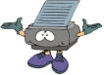 | You will see this symbol whenever you need to print something out. There will also be instructions telling you what you should be printing.
Lesson 1
Selecting and organising content for a presentation.

Today you will learn
- to plan and design a presentation all about you.
- to think about what other pupils will want to know about you and why
- to think about what order the information should be in.

You must complete by the end of this lesson

 | Pupil | Teacher
- Complete the PowerPoint introduction task.
- Create an initial design on paper for your presentation.
- Begin your presentation in Microsoft PowerPoint
- Use promote and demote buttons to arrange your presentation

For homework

Collect some pictures at home that you might want to use in your presentation. For example, images on a floppy disc, photographs, images from magazines etc.
Bring these into the next lesson.
PowerPoint worksheet
This is a slide

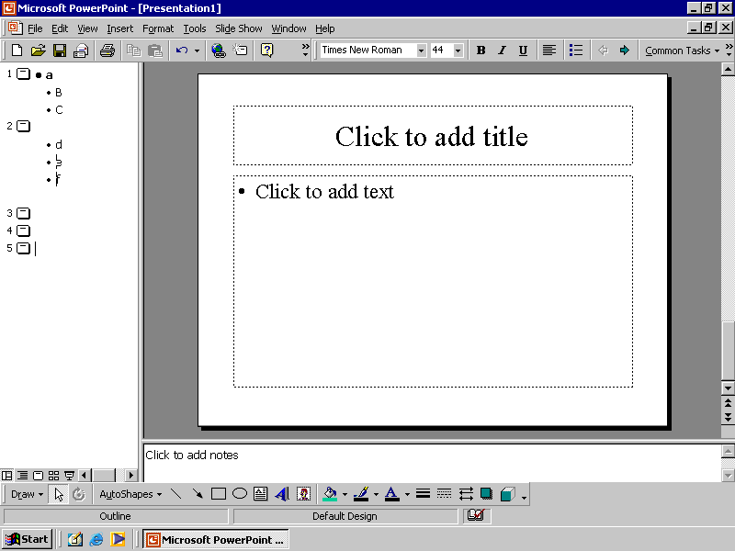
I can click here to find a menu that will let me insert images and sounds
I can change the font size here
This is where I can promote and demote slides.
This is where I can change the type of font I use.
I can use this to make text bold.
I can use this to find some more toolbar icons.
I can add a new slide by clicking here.
My Presentation Design
Lesson 2
Selecting and using appropriate images.
Pupil | Teacher
Have you completed last week’s homework?

Today you will learn
- to consider a particular audience
- how your presentation needs to fit a purpose
- how different images can be used for different purposes
- how to insert appropriate images into your presentation

Things you must complete by the end of this lesson
 | Pupil | Teacher
- Add appropriate images to your presentation

For homework

Complete the homework sheet entitled “Appropriate Text and Images”.
Think about what you have learnt today about how images can be selected for different purposes.
This is where I can change the type of font.
I can add a new slide by clicking this.
I can use this to find some more toolbar icons.
Lesson 3
Selecting and using appropriate fonts and colours
Have you completed last week’s homework?
Pupil | Teacher

Today you will learn
- to consider a particular audience
- why colour is used in a presentation
- why presentations need a mix of text and images
- how to select and use appropriate fonts and colours for your presentation

Things you must complete by the end of this lesson
 | Pupil | Teacher
- Add appropriate fonts and colours to your presentation and use the worksheet to explain your choices.
- Complete your presentation and print out a
‘handout copy’.

For homework
You need to take home your printout and annotate it.
This means you need to write on your presentation what you might want to change or what you might want to add. You need to give reasons why you think these changes would improve your presentation.

Fonts and Colours Worksheet

Which colours have you chosen and why have you chosen them?

Which style and size of fonts have you used and why have you used them?
Lesson 4
Selecting and using appropriate sounds

Have you completed last week’s homework?
Pupil | Teacher

Today you will learn
- how and why sound is used in a presentation
- to select and use appropriate sounds for your presentation

Things you need to complete by the end of this lesson
 | Pupil | Teacher
- Find and add appropriate sounds to your presentation
- Evaluate the advertisement clip shown and complete the evaluation table.

For homework
Using the worksheet write down what other sounds you would have liked to have included in your presentation and give details of how and why you think these would have improved your presentation.

This is where I can change the type of font.
I can add a new slide by clicking this.
I can use this to find some more toolbar icons.
Sounds Evaluation Worksheet

Watch the advertisement again and complete your evaluation below.

What is the purpose of the advertisement?

Who is it aimed at? Who are the audience?

What sound was used?

Did the sound keep your attention? Why?

Did the sound fit the advertisement images? Why?

Lesson 5
Modifying the presentation for a different audience.
Pupil | Teacher
Have you completed last week’s homework?

Today you will learn
- Presentations need to be changed depending on the audience.
- How your presentation would need to change so it appeals to an adult

Things you need to complete by the end of this lesson

 | Pupil | Teacher
- Using the worksheet complete an evaluation of the ‘Perfect Presentation’
- Using the worksheet provided see if your presentation would appeal to an adult audience.
- Print out your presentation as a handout

For homework
Take home your printed presentation and annotate it to show how you would need to change it so that it would be suitable for an adult audience.

Perfect Presentations Worksheet

How to present to an adult audience

Do | Perfect Presentation | Your Presentation
Use the same background
Use a limited number of colours
Use no more than two fonts
Use a consistent layout
Use sound very sparingly
Use animation very sparingly
Don’t
Use different colours for each slide
Mix fonts
Use clashing colours
Put too much information on one slide
Use lots of sound effects
Lesson 6
Evaluating your presentation
Pupil | Teacher
Have you completed last week’s homework?

Today you will learn
- To evaluate the effectiveness of your own and others presentations.

Things you need to complete by the end of this lesson
 | Pupil | Teacher
- Using the worksheet complete an evaluation of your presentation
- Using the worksheet complete an evaluation of one of your classmates’ presentations.
- Ensure that your booklet is up to date

This is the end of the unit Using ICT.

Well done!

This is where I can change the type of font.
I can add a new slide by clicking this.
I can use this to find some more toolbar icons.
Presentation evaluation sheet – own presentation

How well does the presentation meet the needs of the audience?
Judge the presentation against the criteria in the table below.
Score each with a mark from 1 to 4, where 4 is the best/highest score.
Add a comment to say how one feature could be improved.

Criteria | Score  1–4 | Describe one feature you found less effective. How could it be improved?
Is the background colour suitable?

Is the text colour suitable?

Is the text the right size?

Are the images well placed?

Are the images suitable?

Is sound used effectively?

Are the pages laid out attractively?

Is the content appropriate?

Does the presentation have a good structure?

Presentation evaluation sheet – Friends presentation

How well does the presentation meet the needs of the audience?
Judge the presentation against the criteria in the table below.
Score each with a mark from 1 to 4, where 4 is the best/highest score.
Add a comment to say how one feature could be improved.

Criteria | Score  1–4 | Describe one feature you found less effective. How could it be improved?
Is the background colour suitable?

Is the text colour suitable?

Is the text the right size?

Are the images well placed?

Are the images suitable?

Is sound used effectively?

Are the pages laid out attractively?

Is the content appropriate?

Does the presentation have a good structure?
Achievements
This is where I can change the type of font.
I can add a new slide by clicking this.
I can use this to find some more toolbar icons.
This is where I can change the type of font.
I can add a new slide by clicking this.
I can use this to find some more toolbar icons.
Tick the sentences that best describe the work you have done in these lessons on Using ICT. You can tick sentences in more than one column.
This is where I can change the type of font.
I can add a new slide by clicking this.
I can use this to find some more toolbar icons.

Level 3 | Level 4 | Level 5
I created a presentation with one slide. | I created a presentation with more than one slide. | I planned what slides I needed for my presentation and created more than one of them.
I added some text to a slide. | I added appropriate text to my slides. | I added appropriate text to my slides and explained why I needed it.
I added an image to a slide. | I added appropriate images to my slides. | I added appropriate images to my slides and explained why I had chosen them.
I used colour on a slide  . | I used appropriate colours on my slides. | I used appropriate colours on my slides and explained why I had chosen them.
I used sound on my slide. | I used appropriate sounds on some of my slides. | I used appropriate sounds on some of my slides and explained why I had chosen them.
I made some changes to my presentation to make it better. | I evaluated my presentation to make sure it was suitable for other Year 7 pupils. | I changed my presentation and evaluated it to make sure it was suitable for adults.
Key Words

Tick the words you understand as you progress through these lessons.

animation |  |  | image
annotate |  |  | log on
attribute |  |  | Lowercase
audience |  |  | multimedia network
bitmap |  |  | Plan
bullet point |  |  | presentation software
camera |  |  | public area
copyright |  |  | Purpose
criterion |  |  | Sound
digital scanner |  |  | Speaker
draft |  |  | Template
effective |  |  | Uppercase
evaluate |  |  | Vector
fitness for purpose
home area

Glossary

animation
annotate
attribute
audience
bitmap
bullet point
camera
copyright
criterion
digital scanner
draft
effective
evaluate
fitness for purpose
home area
image
log on
lowercase
multimedia network
plan
presentation software
public area
purpose
sound
speaker
template
uppercase
vector

